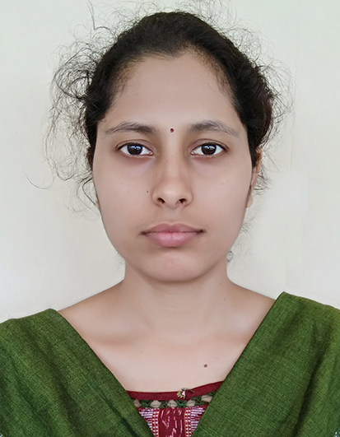
RESUME

ALIBHA PATEL
Mob: 8895417447
Email: alibha456@gmail.com

Objective:
To work for such an organization in which I will get to learn a lot of things and play a significant role in origination’s growth and improvement using my technical knowledge. Want to make my carrier in teaching line, as I think it is the best way to deploy my knowledge.

Educational qualification
Name of the Examination | Name of the institution | Name of the Board/university | Year of passing | Percentage Acquired
10th | Panchayat High School, Arda, Odisha | Board of Secondary Education, Odisha | 2005 | 54.66%
12th | VR college Kundukela, Odisha | CHSE, Odisha | 2007 | 56.88%
B.Tech in Information Technology | KISD, Bhubaneswar, Odisha | BPUT | 2012 | 73.10%
M.Tech in Computer Science and Informatics | ITER, Bhubaneswar, Odisha | Siksha ‘O’ Anusandhan | 2014 | 89.70

Teaching experience:
Post | Period | Organization
Assistant Professor | 3rd Aug 2015 to  18 Aug 2018 | Majhighariani Institute of Technology & Science (MITS), Rayagada, Odisha
Assistant Professor | 20 Aug 2018 to  23 Jan 2019 | Vikash Institute of Technology(VIT), Bargarh, Odisha
Assistant Professor | 25 March 2021 to 30 Aug 2022 | St. Martin’s Engineering College, Hyderabad
Assistant Professor | 02 Sep 2022 to Till date | Malla Reddy University

Software and Hardware credentials:
1 | Working knowledge on 8085 and 8086 microprocessor.
2 | Working knowledge on Intel I5 based systems.
3 | Operating Systems | DOS, Windows-XP,7,8,10, 11 LINUX
4 | Languages | C, C++, JAVA, Python
5 | RDBMS | ORACLE

Personal profile:
Father’s name | Mr. Nabin Chandra Patel
Mother’s name | Mrs. Puspanjali Patel
Date of Birth: | 18/07/1990
Gender: | Female
Nationality: | Indian
Language known: | English, Hindi, Oriya(mt)
Hobbies & Interests: | Swimming & Cooking
Marital Status: | Married
Strength | Sincere, hardworking, loyal, self confident & consistent.

Contact address:
Present | Permanent
Flat No : 215, Sapphire Complex  Amrutha Hills, Officer’s Colony  Punjagutta, Hyderabad, 500082  mail-id:alibha456@gmail.com  Contact no: 8895417447, 7008284643 | At: Kankaramunda  Po: Talmal  Via: OMP Line  Dist: Jharsuguda  Odisha-768204

Declarations:
I do hereby declare that all statements made here are true to the best of my knowledge and belief.

(Alibha Patel)

