|  |
| --- |
| **Ms. DAYANA SEBASTIAN**  **Assistant Professor**  **M.sc in Forensic science** |

|  |
| --- |
| NAME – DAYANA  D/O Sebastian  AMBIPARAMBIL HOUSE  JADKAL  PERMANENT ADDRESS - Ambiparambil house, Beesinapare  Jadkal post  TALUK- Byndoor  DISTRICT - Udupi  STATE- Karnataka  PINCODE-576233  INDIA  EMAIL - [dayanaroy547@gmail.com](mailto:dayanaroy547@gmail.com)  CONTACT NUMBER – 7483351096  LANGUAGES KNOWN – ENGLISH, HINDI,MALAYALAM, KANNADA, TAMIL |

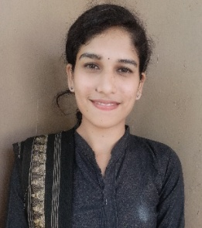**EDUCATIONAL QUALIFICATION**

|  |  |  |  |
| --- | --- | --- | --- |
| Qualification | University | Year passed | Percentage |
| M.Sc in Forensic Science | Manipal University | 2020 | 74% |
| B.sc in life science( Botany,zoology, chemistry) | Mangalore University | 2018 | 74.6% |
| Pre- university | State board | 2015 | 79.6% |
| SSLC | State board | 2013 | 87.36% |

**Personal Skill**

* Good Communication skill.
* Critical thinking skills.
* Observational skills.
* Leadership skill
* Have basic computer knowledge
* Basic knowledge in graphic designing and content creation

**EXPERIENCE**

* Working as Assistant Professor in Malla Reddy University since 17th October 2022
* Worked as Assistant professor in AFC group of institution for 2 years
* Internship in Central Forensic Science Laboratory, Pune
* Project on 'Analysis of Substance Abuse Among Patients in Southern Part of India'

**CONFERENCES ATTENDED**

* Presented on the topic ‘ child abuse and its impact on childs mental health’ at 3 rd global webinar on Forensic science.
* Attended and presented a topic in 2 nd global webinar on Pediatrics and neonatology , october2021
* Presented a topic on ‘ ophitoxemia- In Indian perspective ‘ at 3 rd international conference on forensic research and toxicology 2021-22
* 26th Annual Conference of Karnataka-medicolegal society-KAMLS.
* National Conference on recent advancement in forensic science.
* SPEAR-2019 A hands-on medicolegal for Police, Judiciary and Medical officers.
* Workshop on designer drugs.
* Presented on the topic ‘Cyber Psychology’ at International conference on forensic research 2022-2024